Kuanysh Beibarys SE-2413

Report Assignment 2: Factory, Abstract Factory Patterns

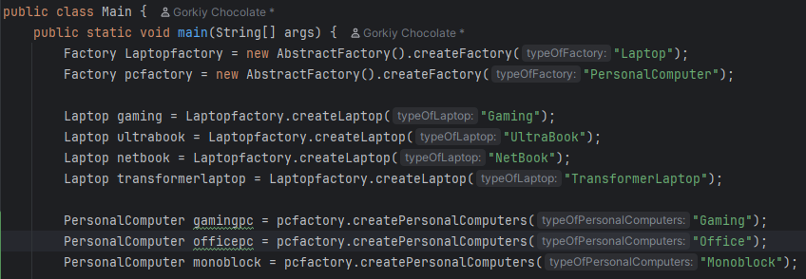

The Main class runs the program.  
It asks AbstractFactory to give factories.  
Then it creates laptops and personal computers.

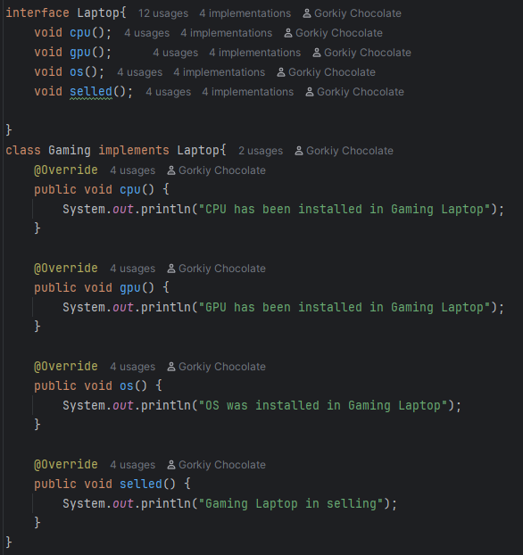  
Laptop is an interface with four methods.  
Gaming, UltraBook, NetBook, TransformerLaptop are classes that implement it.  
They show how each laptop is made and sold.In example, gaming laptop implemenr interface Laptop

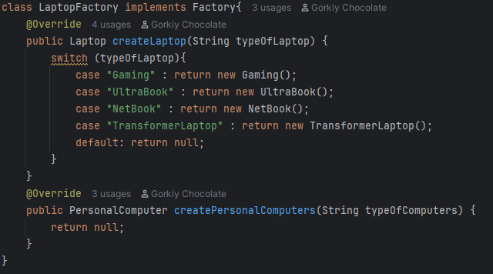  
LaptopFactory creates laptop objects.  
It returns the right laptop using switch.

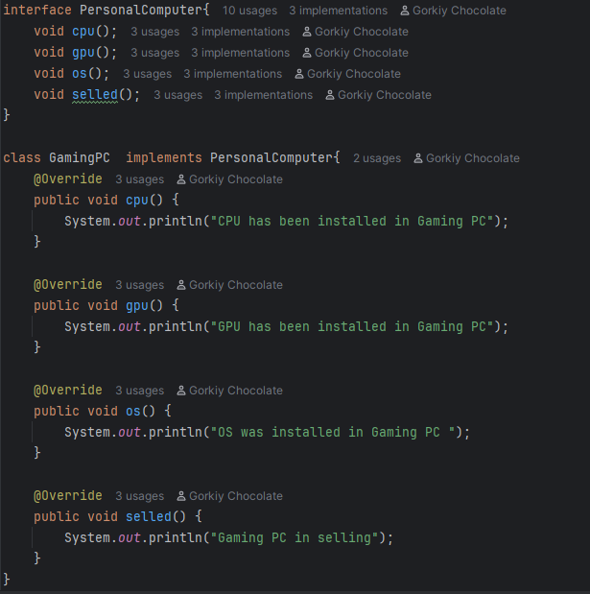

PersonalComputer is an interface with four methods.  
GamingPC, OfficePc, Monoblock are classes that implement it.  
They show how each PC is made and sold

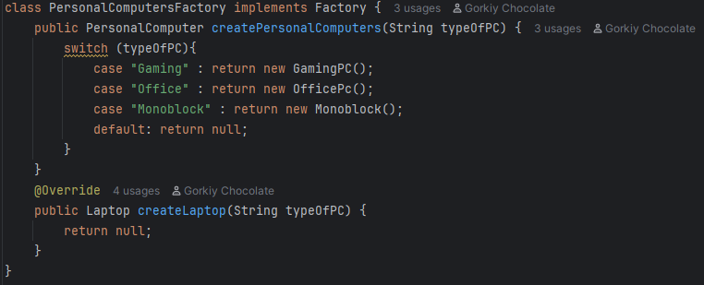

PersonalComputersFactory creates personal computer objects.  
It returns the right PC using switch.

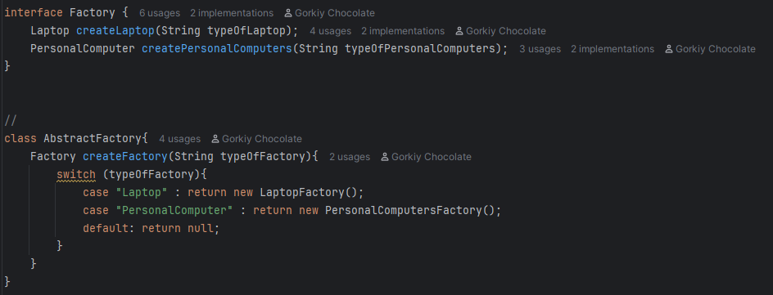  
Factory interface has two methods.  
It connects laptops and personal computers to factories.  
AbstractFactory chooses the right factory.  
It gives LaptopFactory or PersonalComputersFactory.